Ideation Phase

Define the Problem Statements
Date | 13 July 2026
Team ID | SWTID-2026-8803
Project Name | Book Doctor Management System
Maximum Marks | 2 Marks

Customer Problem Statement Template
Create a problem statement to understand your customer's point of view. The Customer Problem Statement template helps you focus on what matters to create experiences people will love.
A well-articulated customer problem statement allows the team to find the ideal solution for the challenges customers face. Throughout the process, the team empathizes with patients, doctors, and administrators to better understand how each perceives the Book Doctor Management System.
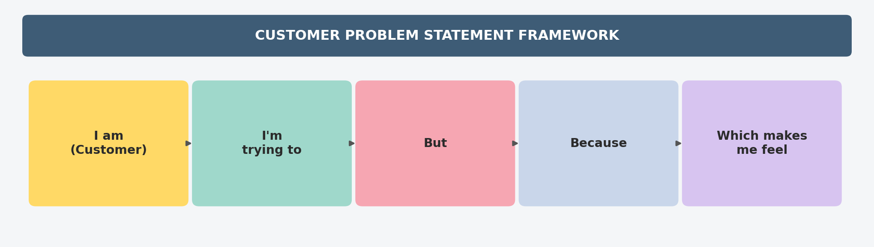

Problem Statements
PS No. | I am (Customer) | I'm trying to | But | Because | Which makes me feel
PS-1 | A patient who needs to see a doctor | book an appointment with a suitable doctor quickly | I have to call the clinic or visit in person just to check availability | there is no real-time online system showing doctor availability and booking status | frustrated and discouraged from seeking timely care
PS-2 | A doctor managing daily patient appointments | keep track of and respond to my appointment requests efficiently | I have limited visibility into upcoming appointments and cannot easily approve, reject, or reschedule them | appointment records are maintained manually in registers or spreadsheets | overwhelmed and worried about missed or double-booked appointments
PS-3 | An administrator overseeing clinic operations | monitor doctors, patients, and appointment activity across the system | I have no centralized dashboard to track this information in real time | user and appointment data is scattered across manual registers with no analytics | unable to make informed decisions or catch scheduling conflicts quickly

